EDUNEXA
System Diagrams
- Class Diagram

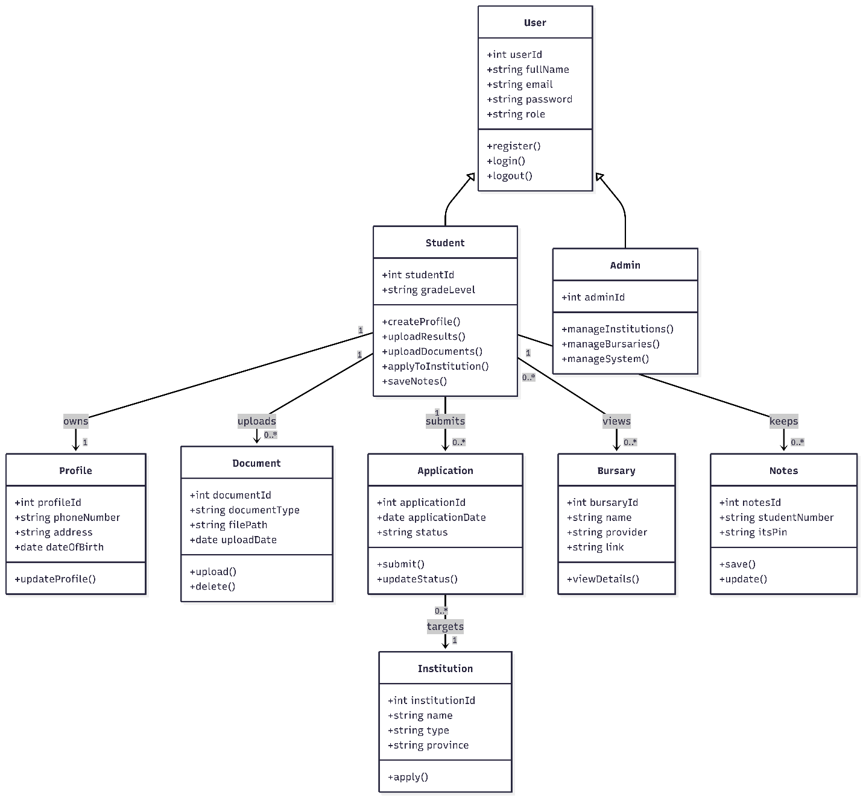

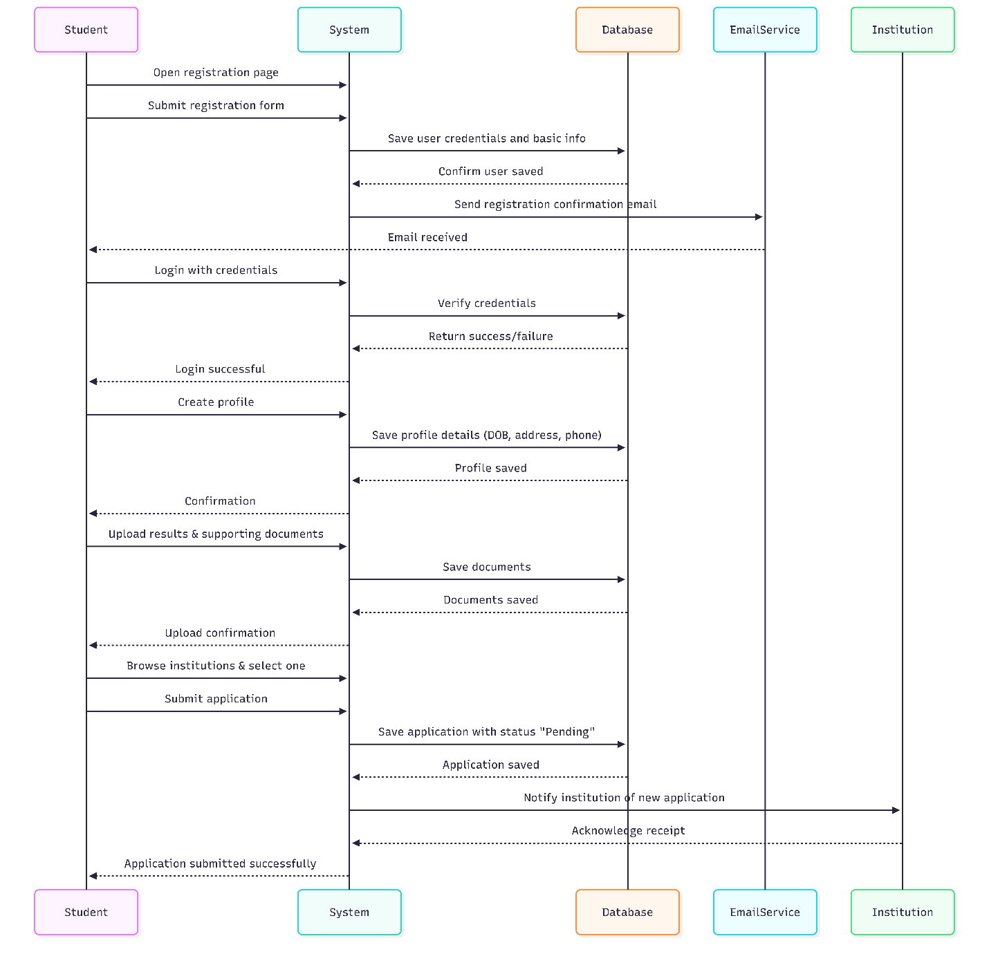
- Sequence Diagram

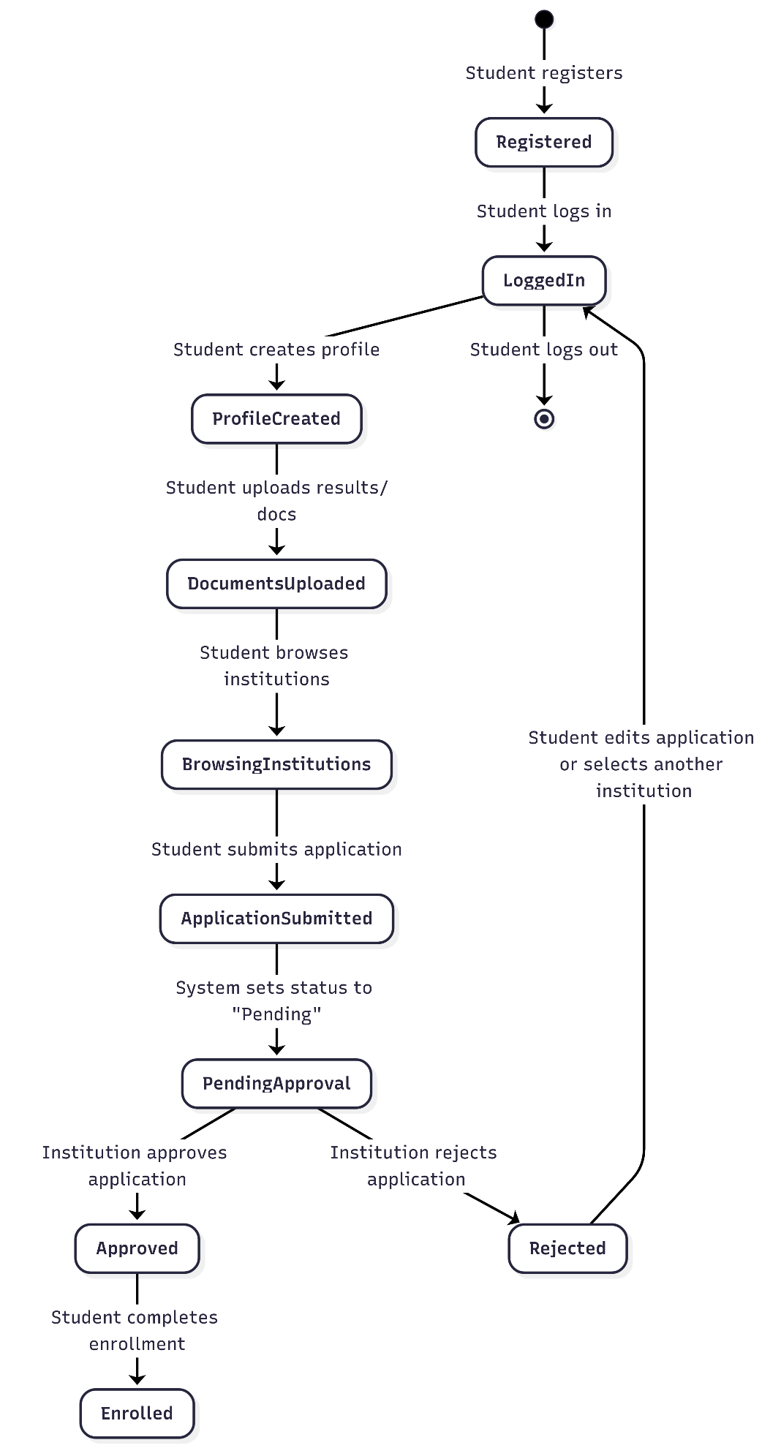
- State Diagram

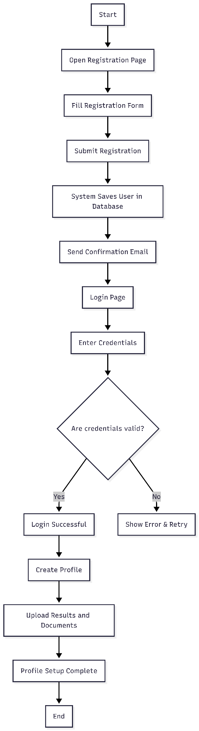
4. Activity Diagram
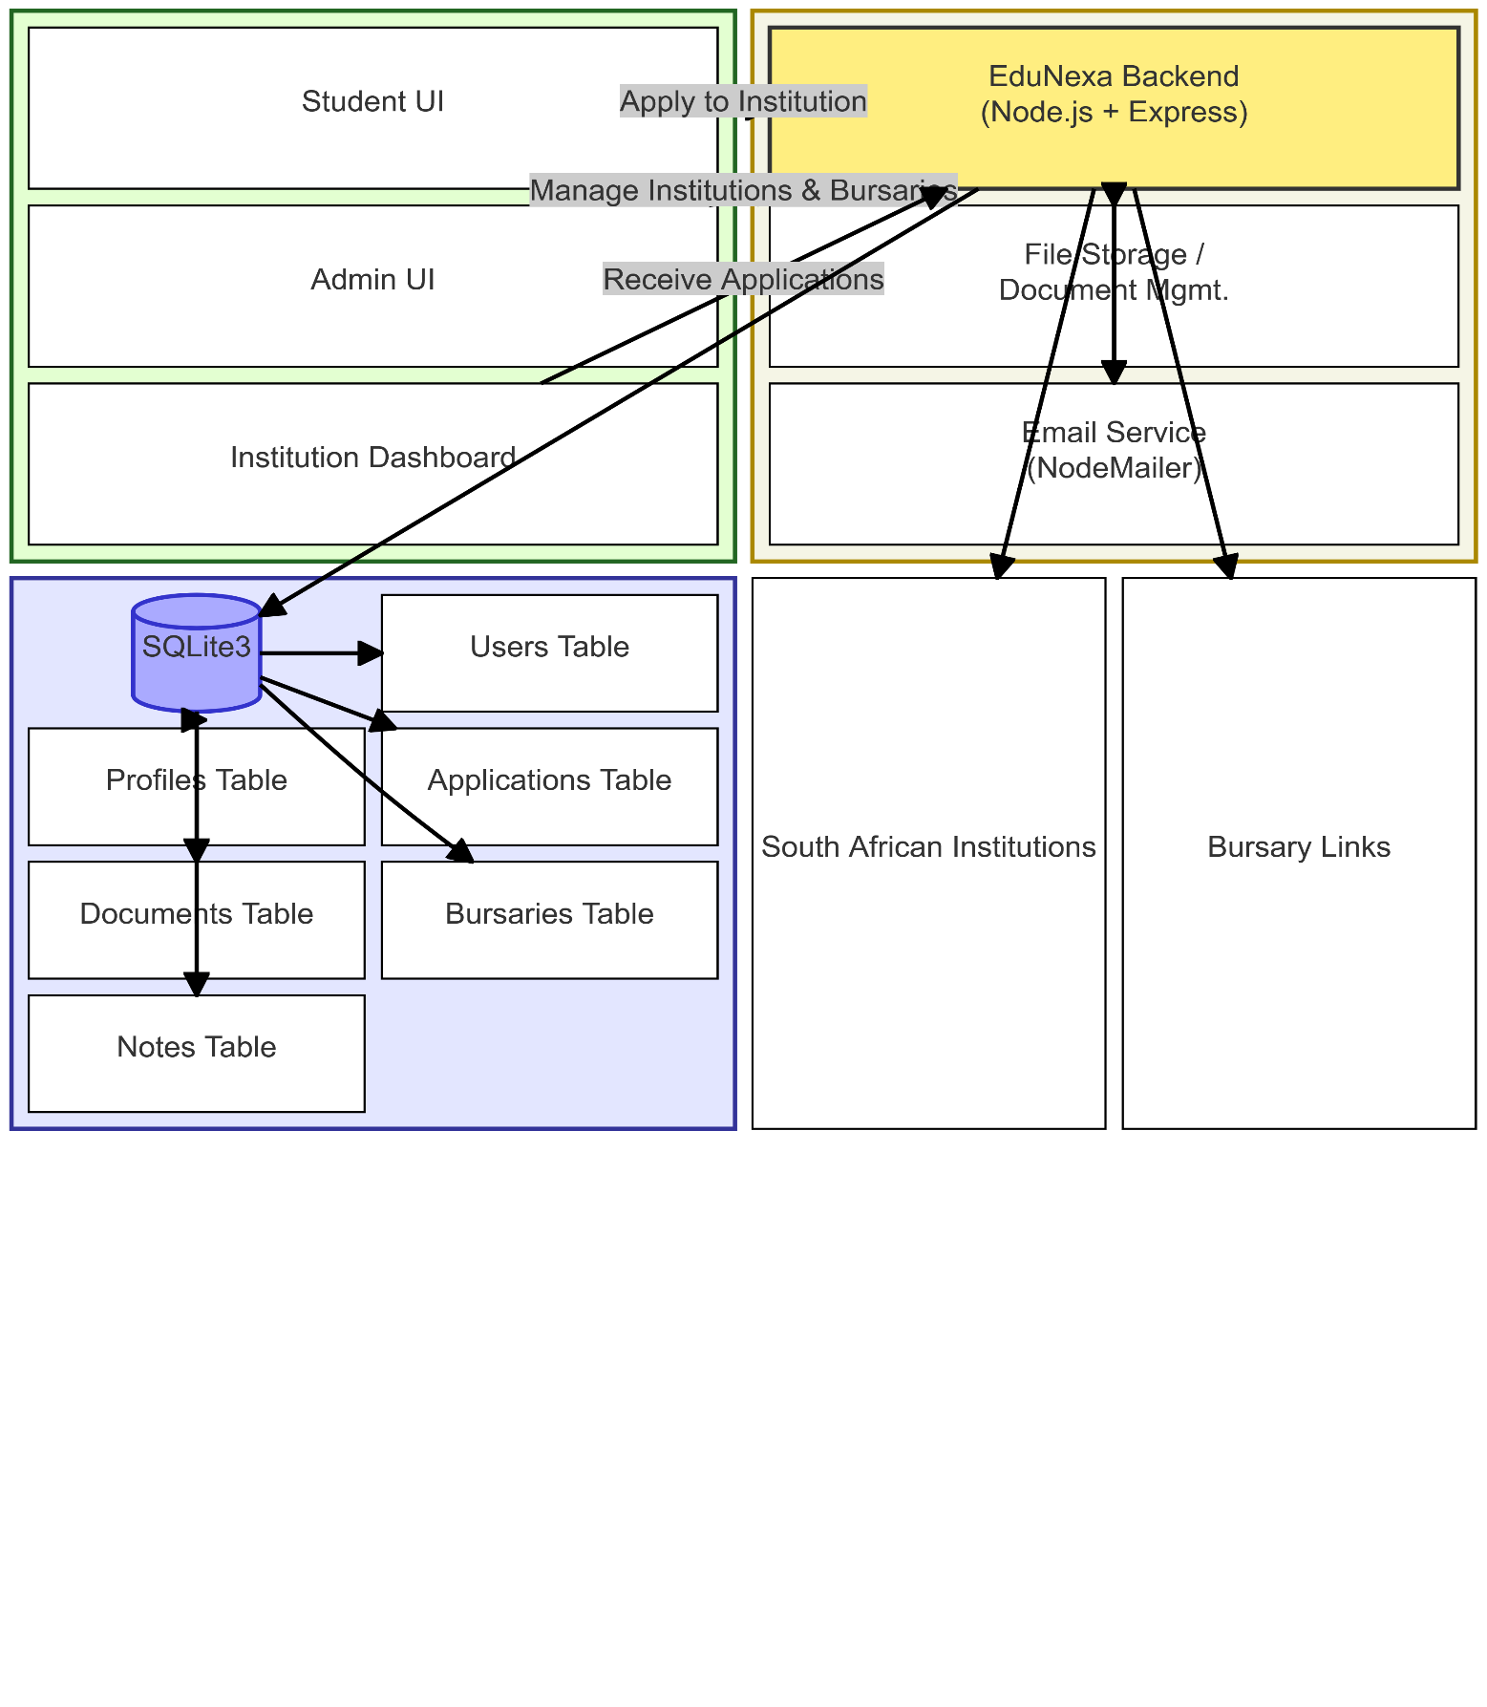
5. Component Diagram

6. Deployment Diagram

